Sri Lanka Institute of Information

Technology



Lab Submission

<Lab sheet No 05>

**<IT24101350>**

**<Hansanganee H.R.S.S>**

**Probability and Statistics| IT2120**

B.Sc. (Hons) in Information Technology

**Exercise**

1)

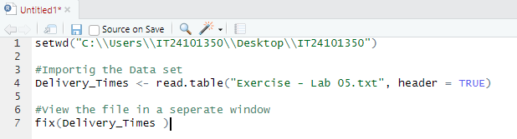

2) 

